Overview
ICH-GCP E6 (R3) introduces the term service provider to encompass any third party performing trial-related activities on behalf of sponsors or investigators. Service providers include central laboratories, data management vendors, and electronic system vendors. This shift reflects the modern clinical trial environment where many specialized vendors support trial operations and data systems.
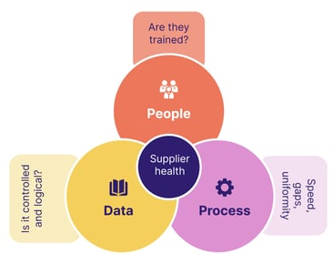

Key Takeaways

- Responsibility: Sponsors/investigators may delegate trial activities to service providers, but retain ultimate responsibility for trial conduct, participant safety, and data integrity.
- Oversight: E6(R3) emphasizes risk-based oversight of service providers throughout the trial lifecycle. Sponsors should:
  - Evaluate and qualify service providers before engagement
  - Monitor performance and compliance of services during the trial
  - Establish processes for communication and escalation
  - Ensure issues affecting participant safety or data integrity are addressed promptly
- Agreements: E6(R3) requires formal agreements between sponsors and service providers. Agreements should:
  - Be documented prior to initiating activities
  - Clearly define roles, responsibilities, and delegated tasks
  - Require compliance with Good Clinical Practice (GCP) and trial protocol
  - Include mechanisms for communication and incident reporting (e.g., affecting participant safety or trial reliability).
- Quality Management Systems: Sponsors should evaluate whether the service provider’s quality systems are adequate for the delegated responsibilities, including change control and issue management, data integrity protections, and personnel training.

